AfricaAI: Runbook - USDAGOO – USDA
Summary | We need to scrape the annual USDA “Grains and Oilseeds  Outlook” for wheat, corn, soybeans, soybean meal, and soybean oil.
Source name | United States Department of Agriculture - USDA
Link to the source | https://www.usda.gov/oce/ag-outlook-forum/commodity-outlooks
Dataset name | USDA Grains and Oilseeds Outlook - USDAGOO
Frequency | Annual
SLA | The report is usually published in the second half of February. Start checking the availability of the report daily from the beginning of February.
Expected Time | NA
1. Navigate to the first source URL.
https://www.usda.gov/oce/ag-outlook-forum/commodity-outlooks
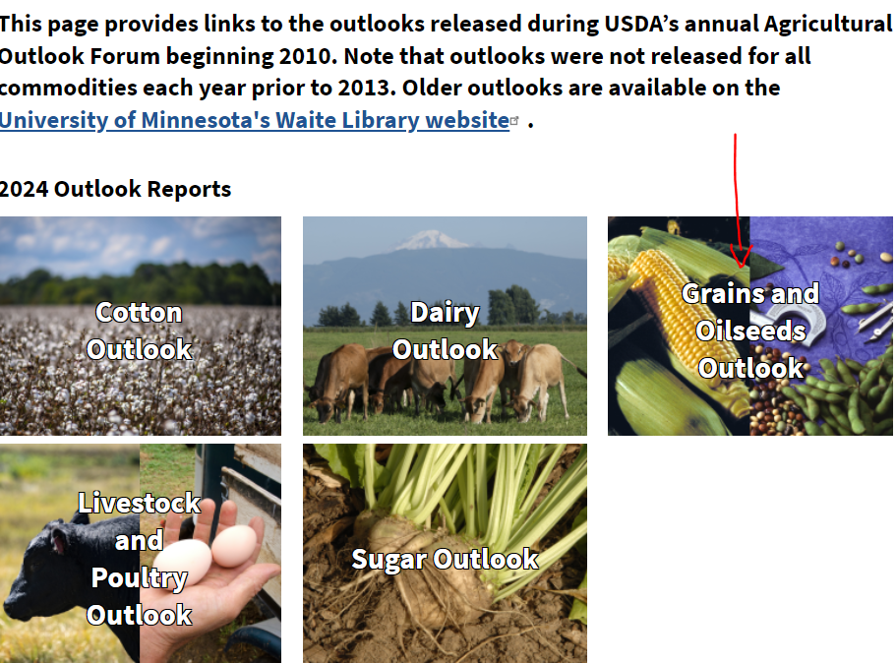

2. Open PDF annual report and collect each available line item for each available period from the tables described below (collect each data period as annual data point, for example: 2021/22 = “2021”.
2.1. Find “Corn Supply, Demand, and Price” table:
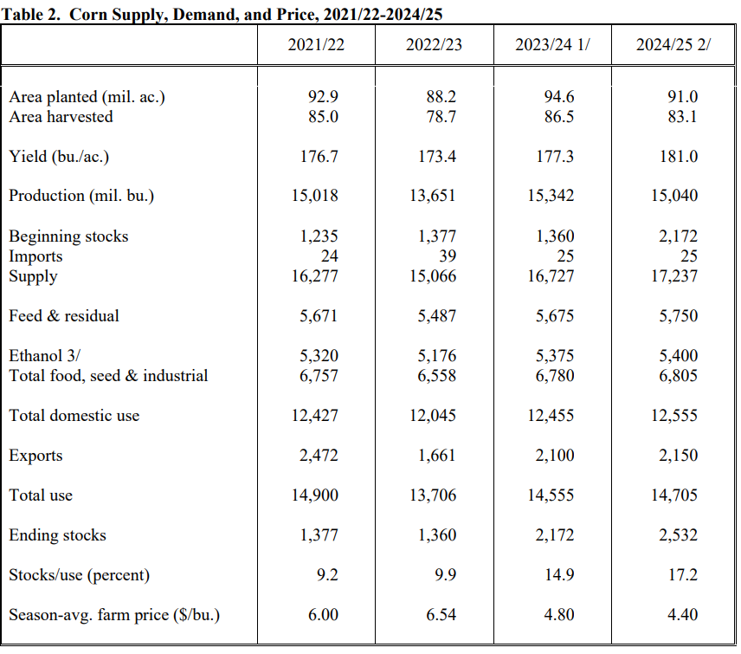
Code | Description
USDAGOO.CORNSDP.AREAPLANTED.A | Corn Supply, Demand, and Price, Area planted (mil. ac.)
USDAGOO.CORNSDP.AREAHARVESTED.A | Corn Supply, Demand, and Price, Area harvested
USDAGOO.CORNSDP.YIELD.A | Corn Supply, Demand, and Price, Yield (bu./ac.)
USDAGOO.CORNSDP.PRODUCTION.A | Corn Supply, Demand, and Price, Production (mil. bu.)
USDAGOO.CORNSDP.BEGINNINGSTOCKS.A | Corn Supply, Demand, and Price, Beginning stocks
USDAGOO.CORNSDP.IMPORTS.A | Corn Supply, Demand, and Price, Imports
USDAGOO.CORNSDP.SUPPLY.A | Corn Supply, Demand, and Price, Supply
USDAGOO.CORNSDP.FEEDRESIDUAL.A | Corn Supply, Demand, and Price, Feed & residual
USDAGOO.CORNSDP.ETHANOL.A | Corn Supply, Demand, and Price, Ethanol
USDAGOO.CORNSDP.FOODSEEDOTHERINDUSTRIAL.A | Corn Supply, Demand, and Price, Food, seed & other industrial
USDAGOO.CORNSDP.TOTALFOODSEEDINDUSTRIAL.A | Corn Supply, Demand, and Price, Total food, seed & industrial
USDAGOO.CORNSDP.TOTALDOMESTICUSE.A | Corn Supply, Demand, and Price, Total domestic use
USDAGOO.CORNSDP.EXPORTS.A | Corn Supply, Demand, and Price, Exports
USDAGOO.CORNSDP.TOTALUSE.A | Corn Supply, Demand, and Price, Total use
USDAGOO.CORNSDP.ENDINGSTOCKS.A | Corn Supply, Demand, and Price, Ending stocks
USDAGOO.CORNSDP.STOCKSUSE.A | Corn Supply, Demand, and Price, Stocks/use (percent)
USDAGOO.CORNSDP.SEASONAVGFARMPRICE.A | Corn Supply, Demand, and Price, Season-avg. farm price ($/bu.)
USDAGOO.CORNSDP.FARMPRICE.A | Corn Supply, Demand, and Price, Farm Price ($/bushel)

2.2. Find table “Soybean Supply, Demand, and Price”:

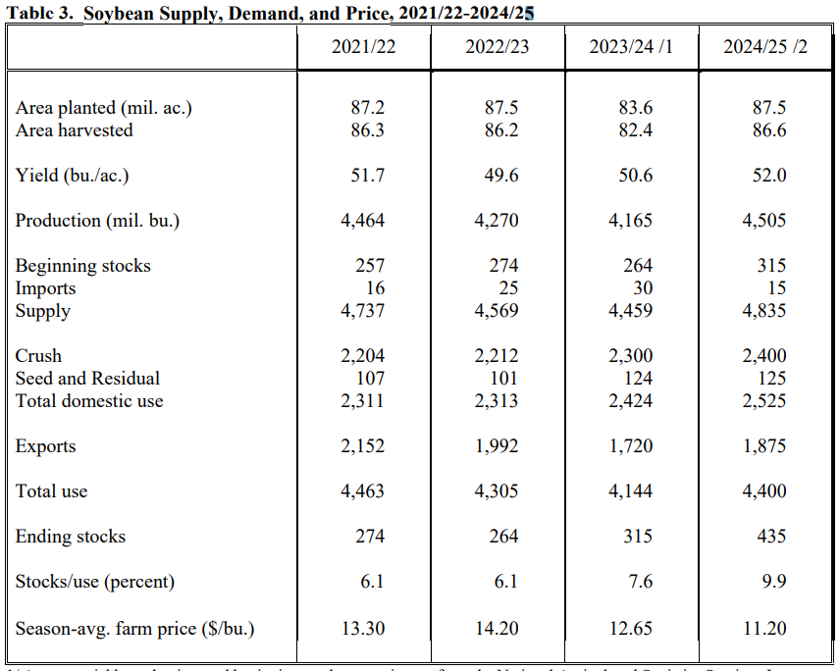
code | description
USDAGOO.SOYBEANSDP.AREAPLANTED.A | Soybean Supply, Demand, and Price, Area planted (mil. ac.)
USDAGOO.SOYBEANSDP.AREAHARVESTED.A | Soybean Supply, Demand, and Price, Area harvested
USDAGOO.SOYBEANSDP.YIELD.A | Soybean Supply, Demand, and Price, Yield (bu./ac.)
USDAGOO.SOYBEANSDP.PRODUCTION.A | Soybean Supply, Demand, and Price, Production (mil. bu.)
USDAGOO.SOYBEANSDP.BEGINNINGSTOCKS.A | Soybean Supply, Demand, and Price, Beginning stocks
USDAGOO.SOYBEANSDP.IMPORTS.A | Soybean Supply, Demand, and Price, Imports
USDAGOO.SOYBEANSDP.SUPPLY.A | Soybean Supply, Demand, and Price, Supply
USDAGOO.SOYBEANSDP.CRUSH.A | Soybean Supply, Demand, and Price, Crush
USDAGOO.SOYBEANSDP.SEEDANDRESIDUAL.A | Soybean Supply, Demand, and Price, Seed and Residual
USDAGOO.SOYBEANSDP.SEED.A | Soybean Supply, Demand, and Price, Seed
USDAGOO.SOYBEANSDP.RESIDUAL.A | Soybean Supply, Demand, and Price, Residual
USDAGOO.SOYBEANSDP.TOTALDOMESTICUSE.A | Soybean Supply, Demand, and Price, Total domestic use
USDAGOO.SOYBEANSDP.EXPORTS.A | Soybean Supply, Demand, and Price, Exports
USDAGOO.SOYBEANSDP.TOTALUSE.A | Soybean Supply, Demand, and Price, Total use
USDAGOO.SOYBEANSDP.ENDINGSTOCKS.A | Soybean Supply, Demand, and Price, Ending stocks
USDAGOO.SOYBEANSDP.STOCKSUSE.A | Soybean Supply, Demand, and Price, Stocks/use (percent)
USDAGOO.SOYBEANSDP.SEASONAVGFARMPRICE.A | Soybean Supply, Demand, and Price, Season-avg. farm price ($/bu.)
USDAGOO.SOYBEANSDP.FARMPRICE.A | Soybean Supply, Demand, and Price, Farm Price ($/bushel)

2.3. Find table “Soybean Meal Supply, Demand, and Price”:

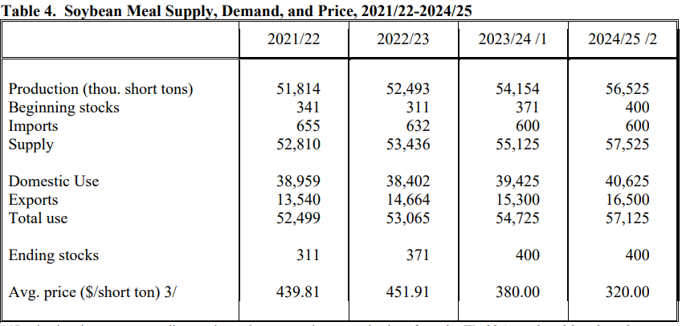

code | description
USDAGOO.SOYBEANMEALSDP.PRODUCTION.A | Soybean Meal Supply, Demand, and Price, Production (thou. short tons)
USDAGOO.SOYBEANMEALSDP.BEGINNINGSTOCKS.A | Soybean Meal Supply, Demand, and Price, Beginning stocks
USDAGOO.SOYBEANMEALSDP.IMPORTS.A | Soybean Meal Supply, Demand, and Price, Imports
USDAGOO.SOYBEANMEALSDP.SUPPLY.A | Soybean Meal Supply, Demand, and Price, Supply
USDAGOO.SOYBEANMEALSDP.DOMESTICUSE.A | Soybean Meal Supply, Demand, and Price, Domestic Use
USDAGOO.SOYBEANMEALSDP.EXPORTS.A | Soybean Meal Supply, Demand, and Price, Exports
USDAGOO.SOYBEANMEALSDP.TOTALUSE.A | Soybean Meal Supply, Demand, and Price, Total use
USDAGOO.SOYBEANMEALSDP.ENDINGSTOCKS.A | Soybean Meal Supply, Demand, and Price, Ending stocks
USDAGOO.SOYBEANMEALSDP.AVGPRICE.A | Soybean Meal Supply, Demand, and Price, Avg. price ($/short ton)

2.4. Find table “Soybean Oil Supply, Demand, and Price”:

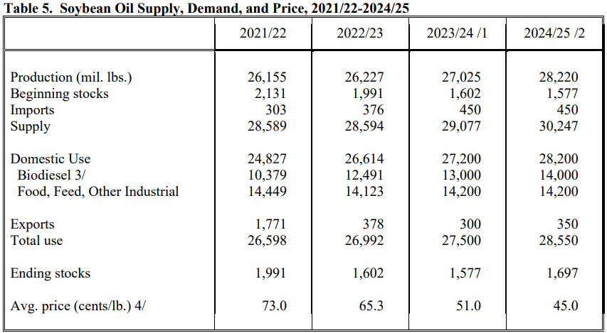
code | description
USDAGOO.SOYBEANOILSDP.PRODUCTION.A | Soybean Oil Supply, Demand, and Price, Production (mil. lbs.)
USDAGOO.SOYBEANOILSDP.BEGINNINGSTOCKS.A | Soybean Oil Supply, Demand, and Price, Beginning stocks
USDAGOO.SOYBEANOILSDP.IMPORTS.A | Soybean Oil Supply, Demand, and Price, Imports
USDAGOO.SOYBEANOILSDP.SUPPLY.A | Soybean Oil Supply, Demand, and Price, Supply
USDAGOO.SOYBEANOILSDP.DOMESTICUSE.A | Soybean Oil Supply, Demand, and Price, Domestic Use
USDAGOO.SOYBEANOILSDP.METHYLESTER.A | Soybean Oil Supply, Demand, and Price, Methyl Ester
USDAGOO.SOYBEANOILSDP.BIODIESEL.A | Soybean Oil Supply, Demand, and Price, Biodiesel
USDAGOO.SOYBEANOILSDP.FOODFEEDOTHERINDUSTRIAL.A | Soybean Oil Supply, Demand, and Price, Food, Feed, Other Industrial
USDAGOO.SOYBEANOILSDP.EXPORTS.A | Soybean Oil Supply, Demand, and Price, Exports
USDAGOO.SOYBEANOILSDP.TOTALUSE.A | Soybean Oil Supply, Demand, and Price, Total use
USDAGOO.SOYBEANOILSDP.ENDINGSTOCKS.A | Soybean Oil Supply, Demand, and Price, Ending stocks
USDAGOO.SOYBEANOILSDP.AVGPRICE.A | Soybean Oil Supply, Demand, and Price, Avg. price (cents/lb.)

2.5. Find table “Wheat Supply, Demand, and Price”:
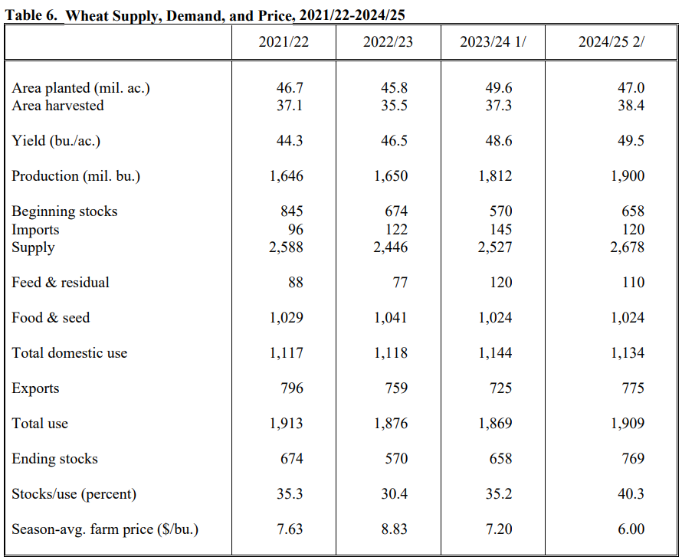
code | description
USDAGOO.WHEATSDP.AREAPLANTED.A | Wheat Supply, Demand, and Price, Area planted (mil. ac.)
USDAGOO.WHEATSDP.AREAHARVESTED.A | Wheat Supply, Demand, and Price, Area harvested
USDAGOO.WHEATSDP.YIELD.A | Wheat Supply, Demand, and Price, Yield (bu./ac.)
USDAGOO.WHEATSDP.PRODUCTION.A | Wheat Supply, Demand, and Price, Production (mil. bu.)
USDAGOO.WHEATSDP.BEGINNINGSTOCKS.A | Wheat Supply, Demand, and Price, Beginning stocks
USDAGOO.WHEATSDP.IMPORTS.A | Wheat Supply, Demand, and Price, Imports
USDAGOO.WHEATSDP.SUPPLY.A | Wheat Supply, Demand, and Price, Supply
USDAGOO.WHEATSDP.FEEDRESIDUAL.A | Wheat Supply, Demand, and Price, Feed & residual
USDAGOO.WHEATSDP.FOODSEED.A | Wheat Supply, Demand, and Price, Food & seed
USDAGOO.WHEATSDP.FOODSEEDINDUSTRIAL.A | Wheat Supply, Demand, and Price, Food, seed & industrial
USDAGOO.WHEATSDP.TOTALDOMESTICUSE.A | Wheat Supply, Demand, and Price, Total domestic use
USDAGOO.WHEATSDP.EXPORTS.A | Wheat Supply, Demand, and Price, Exports
USDAGOO.WHEATSDP.TOTALUSE.A | Wheat Supply, Demand, and Price, Total use
USDAGOO.WHEATSDP.ENDINGSTOCKS.A | Wheat Supply, Demand, and Price, Ending stocks
USDAGOO.WHEATSDP.STOCKSUSE.A | Wheat Supply, Demand, and Price, Stocks/use (percent)
USDAGOO.WHEATSDP.SEASONAVGFARMPRICE.A | Wheat Supply, Demand, and Price, Season-avg. farm price ($/bu.)
USDAGOO.WHEATSDP.FARMPRICE.A | Wheat Supply, Demand, and Price, Farm Price ($/bushel)

3. Save data in USDAGOO_DATA_YYYYMMDD file.

Historical data collection:
We need help in collecting historical data.
This report has 30 years of releases available:
- These are available via PDFs on the USDA's website from 2010 to 2024 via main link:
https://www.usda.gov/oce/ag-outlook-forum/commodity-outlooks
- From 1995 to 2009, the reports are available on the University of Minnesota's Waite Library website:
https://ageconsearch.umn.edu/search?ln=en&rm=wrd&sf=&so=d&rg=100&c=AgEcon%20Search&of=hb&p=Grains%20and%20oilseeds%20outlook
You should compile a separate meta and data file in the archive for each release.
In each of the meta files, you need to fill in the release date by adding a column “LAST_RELEASE_DATE” for each line and enter the value in the YYYY-MM-DDTHH:MM:SS format.
Values for each release date you can find in PDF properties, for example:
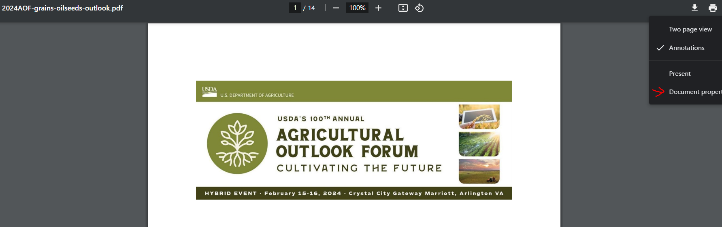
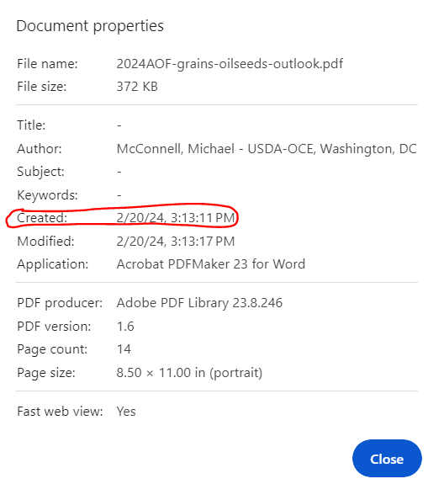
If the creation date is blank, use the modification date. Values for LAST_RELEASE_DATE column for 2024 report: 2024-02-20T15:13:11
In process of filling historical data please note for description of measure, and if cents will be provided in dollars, multiply on 100: for example, in one of historical files mentioned
Soybean Oil Supply, Demand, and Price, Avg. price ($/lb.), it should be (Soybean Oil Supply, Demand, and Price, Avg. price (cents/lb.))*100.

Requirements to the data provided by AfricaAI
Data files format
For on-boarding new datasets and processing new releases the following requirements are applied:
- There should be one archive in .ZIP format that contains 2 files provided in .XLS format per one release - one file with DATA and one file with METADATA (both files are mandatory). Archive name should be as "DATASET_YYYYMMDD.ZIP"", where "DATASET" - specified abbreviation for a dataset, "YYYYMMDD" - timestamp when the file was created, where YYYY - year, MM - month number, DD – day;
- The files format is strictly defined and cannot be changed by the AfricaAI team.

File with DATA
Template for filename: “DATASET_DATA_YYYYMMDD.xls”, i.e.” MEXPENFND_DATA_20220601.xls”
Requirements to the file with DATA:
- format - XLS, encoding - Unicode (UTF-8);
- file name: should follow pattern "DATASET_DATA_YYYYMMDD.xls", where "DATASET" - specified abbreviation for a dataset, "YYYYMMDD" - timestamp when the file was created, where YYYY - year, MM - month number, DD - day;
- file content:
  - data is provided on one sheet only (multiple sheets are forbidden);
  - two-dimensional format where rows represent reported periods and columns contain time series values;
  - reported period(s) should be provided in the following format:
    - for data with daily/ weekdaily frequency: YYYY-MM-DD, where YYYY - year, MM - month, DD – day;
    - for data with weekly frequency: YYYY-WW, where YYYY - year, WW - week number (should be two-digits, i.e. 2022-01, 2022-02, etc.). Week number is defined based on the reporting date: reporting date is considered the end of the week, i.e. if reporting date is Wednesday the week is calculated from Thursday till Wednesday – based on that rule the number of the week is defined;
    - for data with monthly frequency: YYYY-MM, MM - month number (should be two-digits, i.e. 2022-01, 2022-02, etc.);
    - for data with quarterly frequency: YYYY-QX, where YYYY - year, X - quarter number;
    - for data with annual frequency: YYYY, where YYYY – year;
- values to be provided in decimal format with "." as a delimiter (number of digits after "." is limited only by the provided value by the source). In order to interpret data correctly the following requirements are applied:
  - if provider specifies for reported period that data is Not Available (that could provided in corresponding notes or other way) - fill in that data point with "NA" value;
  - if provider does not specify that data is Not Available and report Empty value for reported period - leave Empty cell;
  - if provider skips some of reporting period - skip it also in the file with data as well;
- column names to be provided in two first rows: in the first row - time series ID (CODE), in the second row – time series description (description in DATA file is identical to description in file with METADATA).
NB! Time Series with different frequencies could be provided within the same file as there are different patterns for providing reported periods

File with METADATA
Template for filename: “DATASET_META_YYYYMMDD.xls”, i.e.” MEXPENFND_META_20220601.xls”
Requirements to the file with METADATA:
- format - XLS, encoding - Unicode (UTF-8);
- file name: should follow pattern "DATASET_META_YYYYMMDD.xls", where "DATASET" - specified abbreviation for a dataset, "YYYYMMDD" - timestamp when the file was created, where YYYY - year, MM - month number, DD - day;
- file content: specified metadata attributes that are static unless provider changes something or new time series should be added. In case of new timeseries should be added/ updated/ changed - escalate that to Data Engineering team Special BWAT-DFAC Data Engineering <SpecialBWAT-DFACDataEngineering@epam.com> at and Cc: Data Operations team at Special BWAT-DFAC DataOps <SpecialBWAT-DFACDataOps@epam.com>
Notes on METADATA fields from file “DATASET_META_YYYYMMDD.xls”
- With every data release attach file with METADATA
- With every release change only on attribute in the file with METADATA in column “NEXT_RELEASE_DATE” – set “YYYY-MM_DDThh:mm:ss” (YYYY – year, MM – month, DD – day, hh – hour, mm – minutes, ss – seconds. Time should be provided in UTC time) to the time when the next release is going to be processed.

Saving ZIP archive on SFTP
Save the releases specified per “DATASET” folder (you may create a new folder for new DATASET in case of absence of such folder).
Details on SFTP are the following:
- Dev env
Host: africaai.datadev.dfac.io
- PRODVAL env
Host: africaai.prodval.data-factory.io
- PRODHA env
Host: africaai.prodha.data-factory.io
Port: 22

